**Missile Warning System**

**System Requirement Specification**

Index

1. Scope 2

1.1 Identification 2

1.2 System overview 2

1.3 Document overview 4

2. Referenced documents 4

3. Requirements 5

3.1 States and modes 5

3.2 Functional requirements 5

3.3 External interfaces 5

3.4 Internal nterfaces 5

3.5 Design constraints 5

4. Requirement traceability 5

**History**

|  |  |  |  |
| --- | --- | --- | --- |
| **Date** | **Description** | **Name** | **Version** |
| 17-09-2010 | Initial document | kpi | 1 |
| 18-09-2010 | Format requirements to heading 1 | kpi | 2 |
|  |  |  |  |

**References**

|  |  |  |
| --- | --- | --- |
| **ID** | **Document Name** | **Version** |
| Ref-1 | Therma case.pdf | 1 |
|  |  |  |

**Abbreviations**

|  |  |
| --- | --- |
| UR | User Requirement |
| FR | Functional Requirement |

# Scope

## Identification

This document describes a self protection suite for the F-16 combat aircraft used by the Royal Danish Air Force. The protection suite incorporates a pod for mounting under the left wing and an intelligent cockpit control unit for controlling the system. In the pod is mounted a Missile Warning System (MWS) which gives input to the cockpit control unit. From the cockpit control unit is the dispensing of flares and chaffs from the pod controlled. The solution shall provide warning upon detection of missile threats and be able to automatically dispense payloads in response.

The MWS will be provided as Government Furnished Equipment (GFE) and be physically installed by your company.

If there where more information about the system it should also be placed here, that could be information about which version and type of MWS system that shall be mounted.

## System overview

The system is a self protection suite for a F-16 combat aircraft , it shall protect the aircraft against missile attacks. The system consists of 2 main systems:

* Cockpit Unit, which communicate with the systems in the POD and Aircraft Mission Computer. Has also an interface to the aircraft intercom system and an interface for the user to control the system.
* POD, which holds magazines for flares and chaffs and what is needed for firing them of, plus the MWS system.

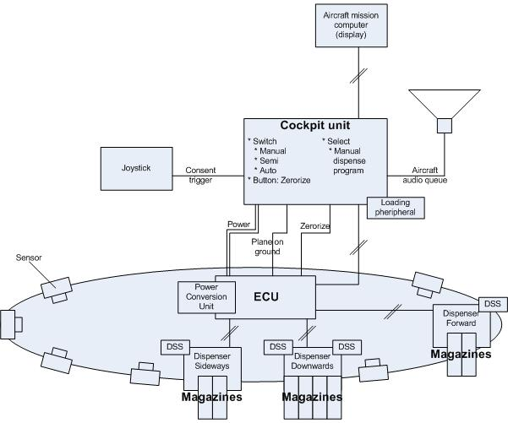

Missiles shall be detected by the MWS that are provided as a GFE equipment and mounted by Company F. When missile attacks are detected information is sent to the cockpit control unit, which depending on the mode it is in will react on the information and is able to react according to a number of programs by dispensing flares and chaffs according to the program chosen. By the interface to the aircraft intercom system audio cues and warnings can be provided.

The system has a number of different users depending on what is done and where:

* On ground the system can be maintained by technicians that update SW and control the system
* Ground personnel shall be able to mount it and when ready to takeoff arm it.
* The pilot shall use the system, by choosing an appropriate program and depending on program chosen do further to let it dispense when missile attacks are detected.
* After dispensing has happened maintenance has to be done again to fill up the magazines again with flares and chaffs.

Other relevant documents for this system are:

* Technical description of MWS system. Document number xxx
* Mechanical description of MWS system. Document number xxx
* User handbook of MWS system. Document number xxx

System overview. This paragraph shall briefly state the purpose of the system to which

this document applies. It shall describe the general nature of the system; summarize the history

of system development, operation, and maintenance; identify the project sponsor, acquirer, user,

developer, and support agencies; identify current and planned operating sites; and list other

relevant documents.

## Document overview

This document shall describe all the Systems Requirements for the Self Protection System for the F-16 combat aircraft and the development of the system shall be based on this document, when the system fulfil the requirements in this document the requirement of the Royal Danish Air Force is fulfilled.

This document must only be used in the project group by Company F and project group and other personal at The Royal Danish Air force that are cleared to have access to this project.

Document overview. This paragraph shall summarize the purpose and contents of this

document and shall describe any security or privacy considerations associated with its use.

# Referenced documents

* Terma case.pdf Document received from TERMA at IHA 3/9 2010.
* Terma case comments v1.pdf
* Terma case meeting 17 9 2010 at IHA v1.pdf
* Terma case questions and answers v1.pdf. Answers received at consultation meeting at IHA 17/9 2010 room 517.
* MIL standard 1600-2-9 v12.45 – POD design rules.

This section shall list the number, title, revision, and date of all

documents referenced in this specification. This section shall also identify the source for all

documents not available through normal Government stocking activities.

# Requirements

|  |  |
| --- | --- |
| **REQ ID** | **Requirement** |
| FR-1 |  |

## States and modes

The system shall be able to work in 2 different states:

* Armed: In this state the system is able to react on information from the MWS system and depending on which mode it is set to by the pilot (Manuel, Semi automatic or automatic from UR 12 in TBD) it will react according to the mode. But for security reasons there shall also be a “plane on ground” mode, where firing of chaffs and flares are disabled.
* Disarmed: in this state it shall be impossible to fire flares or chaffs even though the MWS system of any reason gives a warning against missile attack. In this state shall it also be possible to update SW in the MWS and run different tests to make sure every part of the system report normal conditions or some information about things that are not correct.



Required states and modes. If the system is required to operate in more than one state

or mode having requirements distinct from other states or modes, this paragraph shall identify and

define each state and mode. Examples of states and modes include: idle, ready, active, postuse

analysis, training, degraded, emergency, backup, wartime, peacetime. The distinction

between states and modes is arbitrary. A system may be described in terms of states only,

modes only, states within modes, modes within states, or any other scheme that is useful. If no

states or modes are required, this paragraph shall so state, without the need to create artificial

distinctions. If states and/or modes are required, each requirement or group of requirements in

this specification shall be correlated to the states and modes. The correlation may be indicated

by a table or other method in this paragraph, in an appendix referenced from this paragraph, or

by annotation of the requirements in the paragraphs where they appear.

## Functional requirements

## External interfaces

## Internal interfaces

## Design constraints

# Requirement traceability

|  |  |  |  |
| --- | --- | --- | --- |
| **REQ ID** | **Requirement (short)** | **Trace ID** | **Reference** |
| FR-1 |  | UR-1 |  |